**Blue Coursework Task 2: Search and Seizure**

**The Scene**

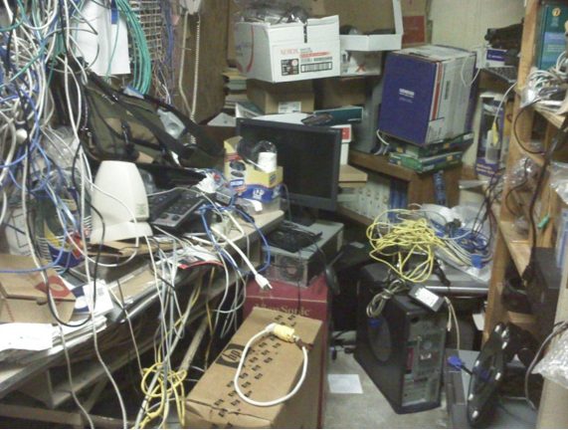

**Fig A – Digital Forensics Search Environment**

**The Search**

In Fig A we can see that, a lot of objects. By searching every detail in this place, we can find that-

* 3 CPU
* 1 Hard-disk on right-below
* A lot of Ethernet cables
* A monitor
* Power Supply
* Keyboard and mouse

For the details investigation, here I need the Hard-disk by which I can investigate of defendant’s-

* Backup files
* Browsing History
* Downloads
* Pictures
* Videos
* Social media Communication
* Passwords and Hidden files.
* Metadata (EXIF, XMP, IPTC)

In this case, for the investigation purpose generally use an autopsy tool.

**Individual Photographs of Evidence**

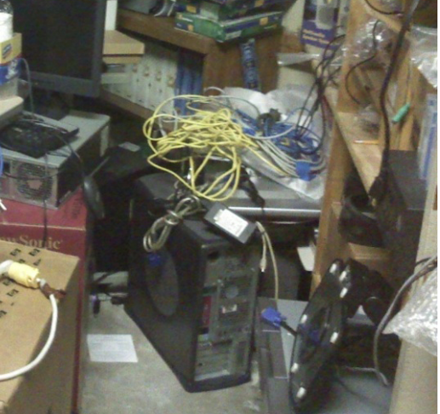

**Hard Disk**

**Evidence No: 1**

**Figure B: A *situ photographs* showing the exhibit reference number of Hard disk**

**Exhibits Record table for your ‘seized’ items:**

|  |  |
| --- | --- |
| CPU | Record Location: On encase spot  Seized by Chief Investigation Officer  Time: 19-11-2022  Seal Number: 2 |
| Hard Disk | Record Location: On encase spot  Seized by Chief Investigation Officer  Time: 19-11-2022  Seal Number: 1 |

For the purpose of investigation, the sealed exhibit is sufficient. Here I seized The CPU and the Hard Disk.